**ONLINE MUSIC SHARING PLATFORM**

**__________________________________________________________________________________________**

**Pranjali Ganvir1, Amisha Ghatole2, Prachi Dharmik3, Akanksha Bangre4, Isha Telmasre5**

**Prof. Omkar Dudhbure6**

12345Student,6Assistant Professor, Dept. of Computer Engineering

Manoharbhai Patel Institute of Engineering & Technology Shahapur, Bhandara, India

**ABSTRACT**

Music sharing is one of the most important components in interactive entertainment. In recent years, mobile music market has experience a rapid growth. Current mainstream music sharing platforms provide users with a large number of online music, which however suffer some limitations of functionality since they neglect the interactions in the physical world. The combination of online music sharing and offline music sharing creates a new music sharing mode. Music Sharing App is a powerful music sharing software that allows users to log into the system, add albums, and add songs to the playlist. All songs listened to by other users registered on the system can also be found in the album. This music software also has music download capabilities, allowing users to listen to music even when they are not connected to the internet. Any user can register for free, and they can all share their music.With increasing demand of information and data. Information Technology is a field which is developing rapidly. Technology which is in demand today might get redundant in future. So, it necessary to provide the latest and most modern IT solutions to various business and other institutions. The objective of this project is to implement Online Music web application with user interface. The motivation of this project comes from my desire to learn the increasingly growing field of Django server database designing, website designing and their growing popularity by taking up this Project. The word "design" in the context of a Web Application can mean many things. Its most popular usage probably refers to the visual and user interface (UI) design of a website. This project covers the following implementations.

The proposed music sharing platform is developed with cloud computing techniques, which relies on sharing of resources and focuses on maximizing the effectiveness of the shared resources. Music sharing on cloud is more convenient and efficient in this case. Experimental results show that this platform can function properly and achieve satisfactory user experience. The purpose of Online Music Portal is to automate the existing manual system by the help of computerized requirements and full-fledged computer software, fulfilling their requirements, so that their valuable data/information can be stored for a longer period with easy accessing and manipulation of the same. The required software and hardware are easily available and easy to work.

**Keywords:** Online Music Platform(OMP), Copyrights, File Sharing(FS), Peer-to-Peer Networks(PPN), Online Music Portal (OMP), Music Streaming Platforms(MSP)

**II. LITERATURE REVIEW**

Many of the articles written about Music sharing platform often refer to them as the modern form of piracy. In the last twenty years, the music industry has gone through many changes due to technological innovations. Technology has had both a negative and a positive effect on the industry. The issue of piracy has existed in the music industry since the beginning, however the nature of it has changed. Piracy as defined by the Oxford English Dictionary refers to the unauthorized reproduction or use of an invention or work of another, as a book, recording, computer software, intellectual property, etc.' ('piracy, n." [1].

Before music was available on CDs, music fans would record their favourite artist's music via cassette tape while the song was being played on the radio. One of the earliest forms of music piracy occurred when people would produce recordings of songs and then sell the recorded songs on cassettes tapes. Initially when CDs became a popular format for audio files, many CDs were coded to restrict the disc from being played on computers, as this was how users could create pirate CDs. People would rip (upload) the files from the CD onto a computer and then burn (copy) the files onto an empty CD[2].

This became the second generation of music piracy. However, due to advances in technology, it has become easier to acquire music for free online. As a result, this has led to an increase in piracy. Online music stores such as Apple's iTunes were seen as a necessary evil in the battle against piracy. Users were given the option of buying music cheaper and many in the industry believed this would offer users the option to morally purchase music rather than download it illegally. However, in more recent years many believe that streaming services such as Spotify have become the most recent case of music piracy. This is because offers its users a free subscription, thus allowing users to listen to music for free[3].

The way music is distributed has developed in line with technology, however the laws regarding copyright and the payments of artists and producers have not been updated to deal with the addition of music streaming services. Gardner (2015) quotes Maria Pallante, the director of the Copyright Office discussing this issue where she states, "the structures that evolved in the previous century to facilitate the lawful exploitation of musical works [4].

**III. METHODOLOGY**

**Admin module:**

The admin module contain the complete details about users and view the details/ information there are some modules like login, user view, etc… the login is use to create a login and sign in to the login. User view contain the user details.

1. LOGIN

2. USER VIEW

**User modules:**

Contain the every user details who register as the user. The people who want to see the songs and the upload / imports the songs of the music sharing platform.

1. REGISTER

2. LOGIN

3. VIEW SONGS.

**A. EXISTING SYSTEM**

The purpose of Online Music Portal is to automate the existing manual system by the help of computerized equipment’s and full-fledged computer software, fulfilling their requirements, so that their valuable data/information can be stored for a longer period with easy accessing and manipulation of the same. The required software and hardware are easily available and easy to work with Online Music Portal, as described above, can lead to error tree, secure, reliable and fast management system. It can assist the user to concentrate on their other activities rather to concentrate on the record keeping. Thus it will help organization in better utilization of resources. The organization can maintain computerized records without redundant entries. That means that one need not be distracted by information that is not relevant, while being able to reach the information. The aim is to automate its existing manual system by the help of computerized equipment’s and full-fledged computer software, fulfilling their requirements, so that their valuable data/information can be stored for a longer period with easy accessing and manipulation of the same. Basically the project describes how to manage for good performance and better services for the clients.

**B. PROPOSED SYSTEM**

Proposed system is a computerized one. This has greater accuracy and efficiency. This takes only limited time for calculation. The proposed system can be used to maintain efficiently the HR Department schedule of any type of company. In larger organizations employees are large. At that time also the proposed system is useful and helpful. E-Music System is not only become a desire of the company but it become the need of the company. The system includes two users Administrator(HR) General User The user gets into the system using user name and a unique password. Each user has his own accessibility permission to accomplish his task flawlessly. Advantages of the proposed system are Easy access to the data The new system is more users friendly, reliable and flexible. Pop-up menus to carry out transactions for a new user. and for other alert messages. Timely Report generation.

**IV. SYSTEM ARCHITECTURE**

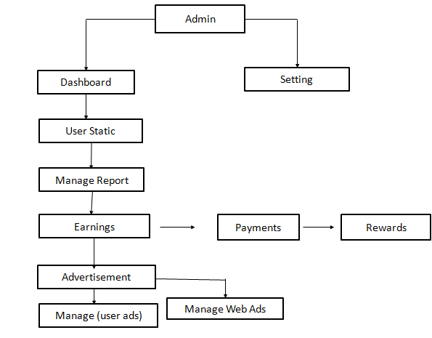

The admin contain the complete details about user and view the user information. There are some modules likes total songs , total users, and total playlist etc…..send the message to users .

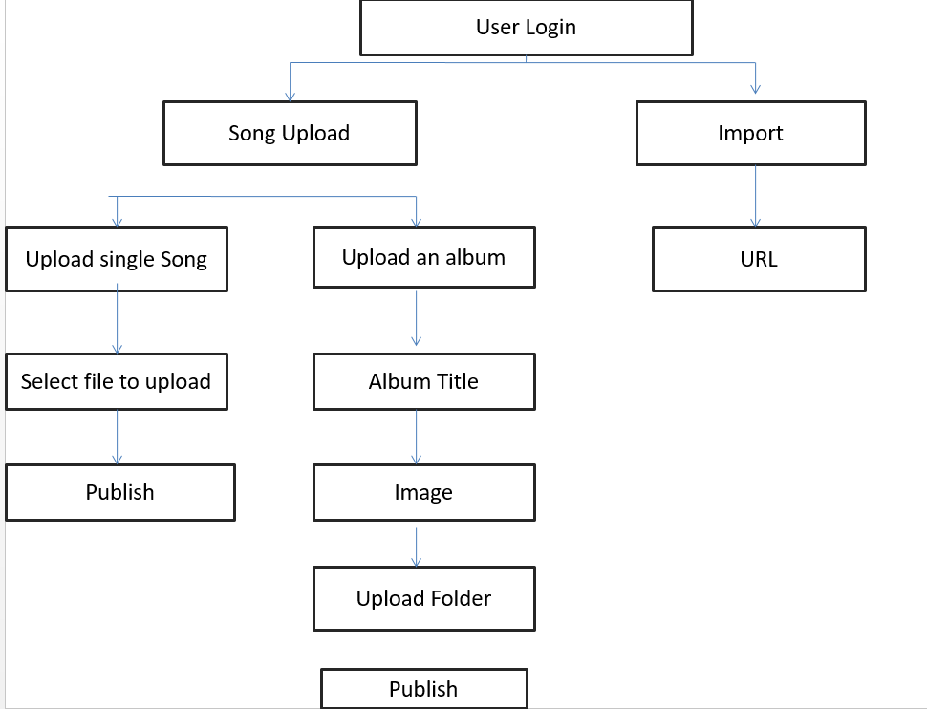

Click your name at the top-right, and then select account from the drop-down list that appears.

**V. ADVANTAGES**

• They help you to access a vast variety of music. • It helps the artists gain more popularity. • Artists can authorize their content • They prevent illegal music downloads.

**VI. CONCLUSION**

• The internet has much more power than the music industry today. • Streaming and online music services have taken. • over digital downloads and physical media • As a result people have easy access to a wider range of music and are able to gain a following online via social media when sharing their own music challenging the traditional notion of record.

**VII. REFERENCES**

1. K. Mohamed and D. Wijeskera, "A lightweight framework for web services implementations on mobile devices", 2012 IEEE First International Conference on Mobile Services, 2012.

2. Brabec, Jeff, Brabec, Todd, 2018. Music Money and Success', Schirmer Trade Books, 8" Ed.

3. Passman, Donald S., 2019, 'All You Need To Know About the Music Business'. Simon & Schuster Publication, 10th Ed.

4. Hesmondhalgh, David, Jones, Ellis, & Rauh, Andreas. (2019). SoundCloud and Bandcamp as alternative music platforms. Social Media + Society, 5(4), 205630511988342. https://doi.org/ 10.1177/2056305119883429 IFPI. (2021). Global music report: Data and analysis for 2020

5. Jones, E. (2019). DIY and popular music: Mapping an ambivalent relationship across three historical case studies. Popular Music and Society, 44(1), 60–78. [https://doi.org/10.1080/03007766. 2019.1671112](https://doi.org/10.1080/03007766.%202019.1671112)

6. Caplan, R., & Gillespie, T. (2020). Tiered governance and demonetization: The shifting terms of labor and compensation in the platform economy. Social Media + Society, 6(2), 205630512093663. https://doi.org/10.1177/2056305120 936636 7. Cooke, C. (2021). Tencent share price dips as Chinese regulator confirms exclusivity deal ban. Retrieved July 27, 2021, from [https://completemusicupdate.com/a rticle/tencent-share-pricedips-aschinese-regulator-confirmsexclusivity-deal-ban/](https://completemusicupdate.com/a%20rticle/tencent-share-pricedips-aschinese-regulator-confirmsexclusivity-deal-ban/)

8. Drott, E. (2018). Music as a technology of surveillance. Journal of the Society for American Music, 12(3), 233–267. [https://doi.org/10.1017/S17521963 18000196](https://doi.org/10.1017/S17521963%2018000196)

9. Haynes, J., & Marshall, L. (2018). Beats and tweets: Social media in the careers of independent musicians. New Media & Society, 20(5), 1973–1993. [https://doi.org/10.1177/1461444817 711404](https://doi.org/10.1177/1461444817%20711404)

10. Hesmondhalgh, David. (2020). Is music streaming bad for musicians? Problems of evidence and argument. New Media & Society, 146144482095354. [https://doi.org/10.1177/1461444820 953541](https://doi.org/10.1177/1461444820%20953541)

11. Ingham, T. (2019). DIY artists will earn more than $1 billion this year. No wonder the major labels want their business. Retrieved December .12, 2020, from https://www.rollingstone.com/pro/ features/diy-artists-will-earn-morethan-1-billion-this-year-no-wonderthe-major-labelswant-theirbusiness-830863/s

12. Drott, E. (2018). Music as a technology of surveillance. Journal of the Society for American Music, 12(3), 233–267. https://doi.org/10.1017/S17521963 18000196